REQUEST FOR QUOTATION
RFQ Reference: RFQ-003-IOMZK-2024 | Date: 26 March 2024
Subject of RFQ: Purchase, delivery and installation of glazed pertitions for new IOM office at Zorza Klemansoa 19, Belgrade.
International Organization for Migration kindly requests your quotation for the provision of the goods, works and/or services described in the RFQ submission form below.
When preparing your quotation, please be guided by the RFQ information below. It is your responsibility to ensure that your quotation is submitted on or before the deadline. Quotations received after the submission deadline, for whatever reason, will not be considered for evaluation.

RFQ INFORMATION
Deadline for the submission of quotation | 28 March 2024, 12.00 (GMT+2)  If any doubt exists as to the time zone in which the quotation should be submitted, refer to http://www.timeanddate.com/worldclock/.
Method of submission | Quotation must be submitted as follows:  ☐ E-tendering  ☒ Email  ☐ Courier / Hand delivery  ☐ Other Click or tap here to enter text.
Cost of preparation of quotation | IOM shall not be responsible for any costs associated with a vendor’s preparation and submission of a quotation, regardless of the outcome or the manner of conducting the selection process.
Contractual Terms | Any Purchase Order that will be issued as a result of this RFQ shall be subject to the IOM standard terms for provision of goods/services/transportation/medical services available at https://www.iom.int/do-business-us-procurement or IOM standard contract templates.
Documents to be submitted | Bidders shall submit and sign the-bid submission form below.
Quotation validity period | The quotation shall remain valid for 30 calendar days days from the deadline for the submission.
Price | Quotations shall be for the goods, works and/or services stated in the Specification/TOR/SOW
Partial quotations | ☒ Not permitted  ☐ Permitted Insert conditions for partial bids and ensure that the requirements are properly listed in lots to allow partial bids
Clarifications | Contact person for correspondence, notifications and clarifications  Contact person: Nebojsa Bogdanovic  E-mail address: nbogdanovic@iom.int
Evaluation method | ☒ The contract will be awarded to the lowest price substantially compliant offer  ☐ Other Click or tap here to enter text.
Right not to accept any quotation | IOM is not bound to accept any quotations, nor award a contract or purchase order
Expected date for contract/PO award. | 01 march 2024

Thank you and we look forward to receiving your quotation.
Issued by:
Signature:
Name: IOM procurement
Title: Click or tap here to enter text.
Date: March 26th, 2024.

QUOTATION SUBMISSION FORM
RFQ Reference: Purchase, delivery and installation of glazed pertitions for new IOM office at Zorza Klemansoa 19, Belgrade. | Date: 26 March 2024
RFQ ref no: RFQ-003-IOMZK-2024

Requirements (Specs/TOR/SOW)
____
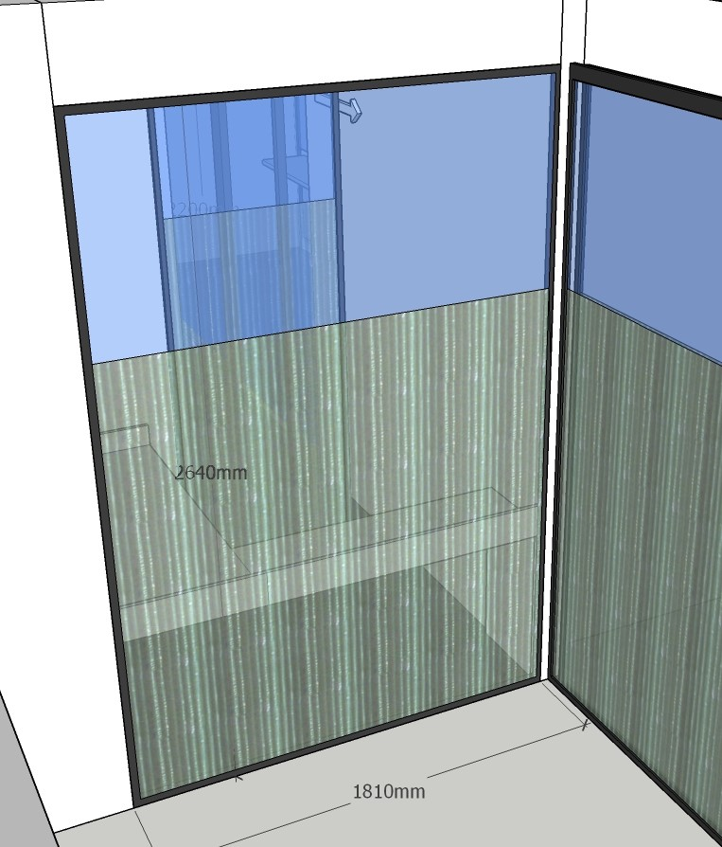

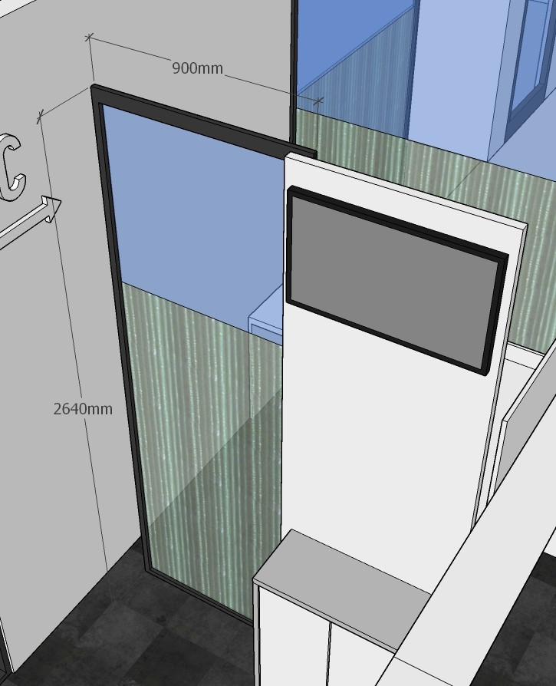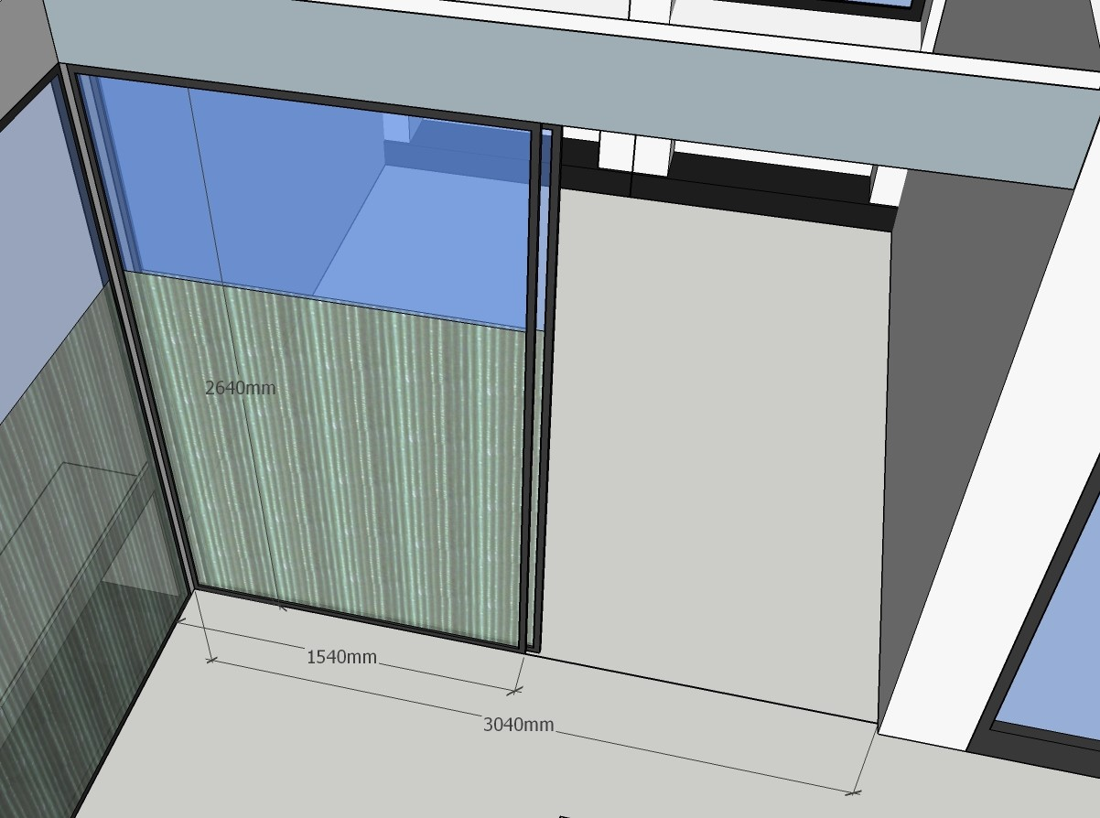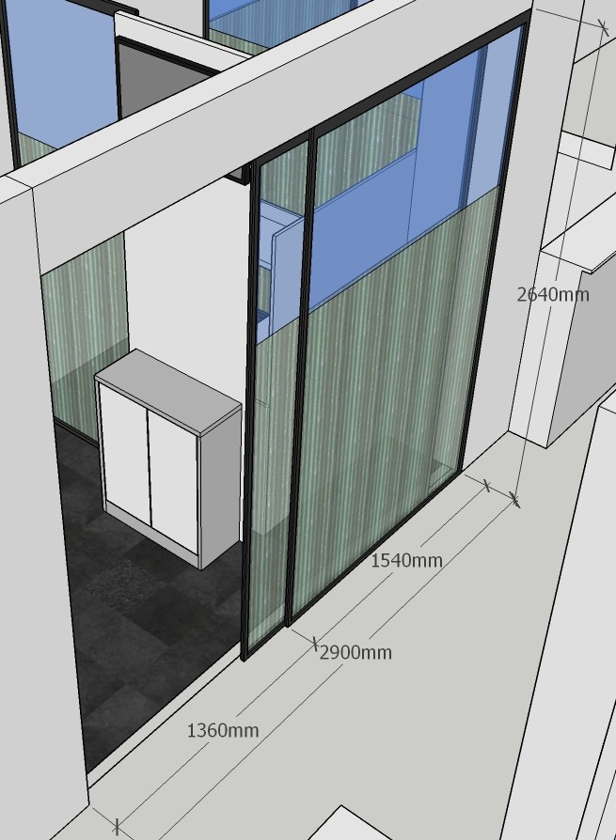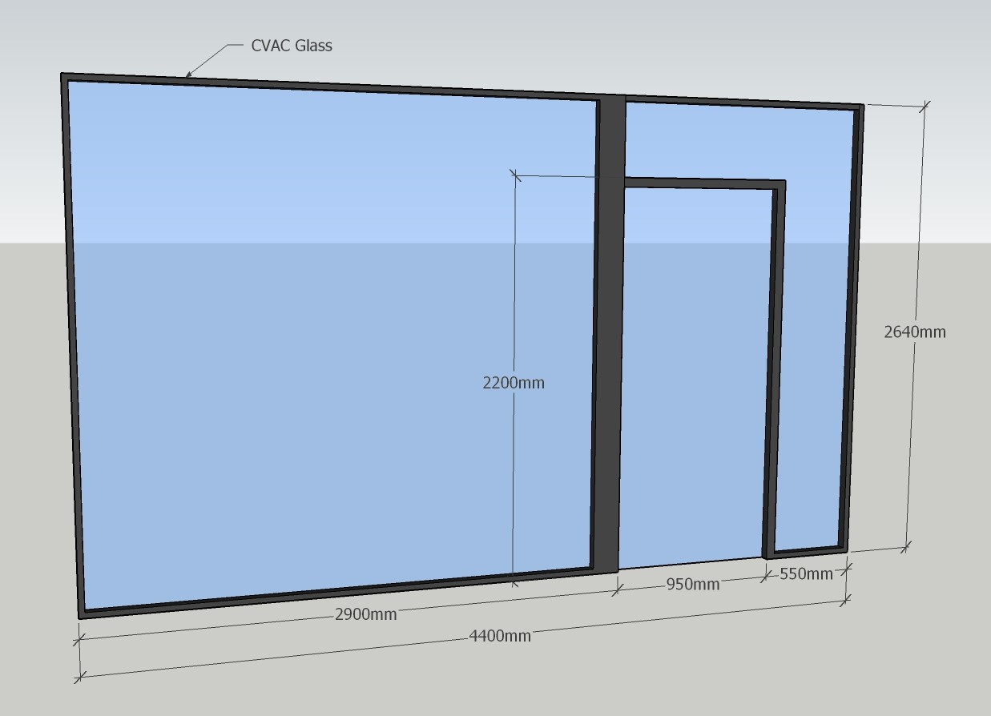

Delivery Requirements:

Currency of the Quotation: RSD
INCOTERMS: N/A
Item No | Description | UOM | Qty | Unit price | Total price
1. | CVAC Ulaz_Automatska unutrašnja klizna vrata u aluminijumskom ramu sa fiksnim dovratnikom. Kačenje u plafon. Klizna vrata dimenzije 1450mmx 2940mm sa fiksnim dovratnikom dimenzije 1500mm x 2940mm. Vrata se otvaraju prilikom ulaza u prosotriju komandom sa recepcije a na izlazu preko tastera ugrađenog na zodu pored otvora za vrata. Ostakljena pampleks staklom 4.4.1. Boja profila RAL 9005 crna matCVAC Entrance_Automatic interior sliding glass door framed in aluminium profiles with a fixed glazed side panel. Railing track fiwed into a ceiling beam. Sliding door dimensions 1450mm x 2940mm with side panel dimensions 1500mm x 2940mm. Form outside the lobby door is controled with a command from the reception desk, and when exiting via a button installed on the wall next to the door opening. The door leaf and side panel are glazed with laminated glass 4.4.1. Profile color RAL9005 black mat. | set | 1
2. | Recepcija_Ostakljena fiksna pregrada od kaljenog stakla d=10mm u aluminijumskom ramu. Boja profila crna RAL9005mat. Staklo kaljeno 10mm flot.Reception_Glazed fixed partition made of tempered glass d=10mm in an aluminum frame. Profile color black RAL9005mat. Tempered glass 10mm float. | set | 1
3. | PC Kiosk_Unutrašnja klizna vrata u aluminijumskom ramu sa rukohvatom. Fiksiranje u plafon. Klizna vrata dimenzije 900mm x 2940mm. Ostakljena pampleks staklom 4.4.1. Boja profila RAL 9005 crna matPC Kiosk_Interior sliding glass door framed in aluminium profiles and handles. Railing track fixed into a ceiling beam. Sliding door dimensions 900mm x 2940mm. The door leaf and side panel are glazed with laminated glass 4.4.1. Profile color RAL9005 black mat. | pcs | 1
4. | IOM Čekaonica_Manuelna unutrašnja klizna vrata u aluminijumskom ramu sa rukohvatom i fiksnim dovratnikom. Kačenje u plafon. Klizna vrata dimenzije 1500mmx 2940mm sa fiksnim dovratnikom dimenzije 1590mm x 2940mm. Ostakljena pampleks staklom 4.4.1. Boja profila RAL 9005 crna matIOM waiting room_Manual interior sliding glass door framed in aluminium profiles with door handle and fixed glazed side panel. Railing track fiwed into a ceiling beam. Sliding door dimensions 1500mm x 2940mm with side panel dimensions 1590mm x 2940mm. The door leaf and side panel are glazed with laminated glass 4.4.1. Profile color RAL9005 black mat. | pcs | 1
5. | CVAC Operacije_Ostakljena fiksna pregrada od kaljenog stakla d=10mm u aluminijumskom ramu. U okviru pregrade se nalaze okretna vrata dimenzije 950x2200mm. Boja profila crna RAL9005mat. Staklo kaljeno 10mm flot.CVAC Operations_Glazed fixed partition made of tempered glass d=10mm in an aluminum frame. Including glass door dimension 950x2200mm. Profile color black RAL9005mat. Tempered glass 10mm float. | pcs | 1
Total Price
Transportation Price
Insurance Price
Installation Price
Training Price
Other Charges (specify)
Total Final and All-inclusive Price

COMPANY PROFILE (Vendor Information Form)
Item Description | Detail
Legal name of bidder* | Click or tap here to enter text.
Legal Address (house no, street name, zip code, city*, region*, country*) | Click or tap here to enter text.
Website | Click or tap here to enter text.
Registration date* and VAT number* | Click or tap here to enter text. Click or tap here to enter text.
Legal structure | Choose an item.
Business type/industry category* | ☐ Direct Producer/Manufacturing ☐ Reseller/Distributor/Service Provider
Are you a UNGM registered vendor? | ☐ Yes ☐ No If yes, insert UNGM Vendor Number
Do you provide services/goods internationally? | ☐ Yes ☐ No If no, in which country: Click or tap here to enter text.
Contact information* | Company Tel/Mobile: Click or tap here to enter text.  Company Email: Click or tap here to enter text.  Company Website: Click or tap here to enter text.  Contact Person 1:Click or tap here to enter text.  Contact Person 2: Click or tap here to enter text.
Disability inclusive business* | ☐ Yes ☐ No
Women-owned/controlled* | ☐ Yes ☐ No
Bank Information | Bank Name: Click or tap here to enter text.  Bank Address: Click or tap here to enter text.  IBAN: Click or tap here to enter text.  SWIFT/BIC: Click or tap here to enter text.  Account Currency: Click or tap here to enter text.  Bank Account Number: Click or tap here to enter text.  Other relevant information: Click or tap here to enter text.

BIDDER’S DECLARATION OF CONFORMITY
Yes | No
☐ | ☐ | On behalf of the vendor, I hereby represent and warrant that neither the vendor, nor any person having powers of representation, decision-making or control over it or any member of its administrative, management or supervisory body, has been the subject of a final judgement or final administrative decision for one of the following reasons: bankruptcy, insolvency or winding-up procedures; breach of obligations relating to the payment of taxes or social security contributions; grave professional misconduct, including misrepresentation, fraud; corruption; conduct related to a criminal organisation; money laundering or terrorist financing; terrorist offences or offences linked to terrorist activities; child labour and other trafficking in human beings, any discriminatory or exploitative practice, or any practice that is inconsistent with the rights set forth in the Convention on the Rights of the Child or other prohibited practices; irregularity; creating or being a shell company.
☐ | ☐ | On behalf of the vendor, I further represent and warrant that the vendor is financially sound and duly licensed.
☐ | ☐ | On behalf of the vendor, I further represent and warrant that the vendor has adequate human resources, equipment, competence, expertise and skills necessary to complete the contract fully and satisfactorily, within the stipulated completion period and in accordance with the relevant terms and conditions.
☐ | ☐ | On behalf of the vendor, I further represent and warrant that the vendor complies with all applicable laws, ordinances, rules and regulations.
☐ | ☐ | On behalf of the vendor, I further represent and warrant that the vendor will in all circumstances act in the best interests of IOM.
☐ | ☐ | On behalf of the vendor, I further represent and warrant that no official of IOM or any third party has received from, will be offered by, or will receive from the vendor any direct or indirect benefit arising from the contract.
☐ | ☐ | On behalf of the vendor, I further represent and warrant that the vendor has not misrepresented or concealed any material facts during the contracting process.
☐ | ☐ | On behalf of the vendor, I further represent and warrant that the vendor will respect the legal status, privileges and immunities of IOM as an intergovernmental organization.
☐ | ☐ | On behalf of the vendor, I further represent and warrant that neither the vendor nor any persons having powers of representation, decision-making or control over the vendor or any member of its administrative, management or supervisory body are included in the most recent Consolidated United Nations Security Council Sanctions List (the “UN Sanctions List”) or are the subject of any sanctions or other temporary suspension. The vendor will immediately disclose to IOM if it or they become subject to any sanction or temporary suspension.
☐ | ☐ | On behalf of the vendor, I further represent and warrant that the vendor does not employ, provide resources to, support, contract or otherwise deal with any person, entity or other group associated with terrorism as per the UN Sanctions List and any other applicable anti-terrorism legislation.
☐ | ☐ | On behalf of the vendor, I further represent and warrant that, the vendor will apply the highest ethical standards, the principles of efficiency and economy, equal opportunity, open competition and transparency, and will avoid any conflict of interest.
☐ | ☐ | On behalf of the vendor, I further represent and warrant that the vendor undertakes to comply with the Code of Conduct, available at https://www.ungm.org/Public/CodeOfConduct.
☐ | ☐ | It is the responsibility of the vendor to inform IOM immediately of any change to the information provided in this Declaration.
☐ | ☐ | On behalf of the vendor, I certify that I am duly authorized to sign this Declaration and on behalf of the vendor I agree to abide by the terms of this Declaration for the duration of any contract entered into between the vendor and IOM.
☐ | ☐ | IOM reserves the right to terminate any contract between IOM and the vendor, with immediate effect and without liability, in the event of any misrepresentation made by the vendor in this Declaration.

Signature:
Name: Click or tap here to enter text.
Title: Click or tap here to enter text.
Date: Click or tap to enter a date.

If company id not registered in UNGM or with IOM. If supplied to IOM already, please indicate if there are any changes to be incorporated in the vendor information sheet signed earlier
This form is mandatory to fill in and sign by every vendor who submits quotation

