REQUEST FOR QUOTATION
RFQ Reference: RFQ-002-IOMZK-2024 | Date: 26 March 2024
Subject of RFQ: Purchase and delivery of custom-made office furniture for new IOM-CVAC office at Zorza Klemansoa 19, Belgrade.
International Organization for Migration kindly requests your quotation for the provision of the goods, works and/or services described in the RFQ submission form below.
When preparing your quotation, please be guided by the RFQ information below. It is your responsibility to ensure that your quotation is submitted on or before the deadline. Quotations received after the submission deadline, for whatever reason, will not be considered for evaluation.

RFQ INFORMATION
Deadline for the submission of quotation | 28 March 2024, 12.00 (GMT+2)  If any doubt exists as to the time zone in which the quotation should be submitted, refer to http://www.timeanddate.com/worldclock/.
Method of submission | Quotation must be submitted as follows:  ☐ E-tendering  ☒ Email  ☐ Courier / Hand delivery  ☐ Other Click or tap here to enter text.
Cost of preparation of quotation | IOM shall not be responsible for any costs associated with a vendor’s preparation and submission of a quotation, regardless of the outcome or the manner of conducting the selection process.
Contractual Terms | Any Purchase Order that will be issued as a result of this RFQ shall be subject to the IOM standard terms for provision of goods/services/transportation/medical services available at https://www.iom.int/do-business-us-procurement or IOM standard contract templates.
Documents to be submitted | Bidders shall submit and sign the-bid submission form below.
Quotation validity period | The quotation shall remain valid for 30 calendar days days from the deadline for the submission.
Price | Quotations shall be for the goods, works and/or services stated in the Specification/TOR/SOW
Partial quotations | ☒ Not permitted  ☐ Permitted Insert conditions for partial bids and ensure that the requirements are properly listed in lots to allow partial bids
Clarifications | Contact person for correspondence, notifications and clarifications  Contact person: IVAN MILTENOVIC  E-mail address: imiltenovic@iom.int
Evaluation method | ☒ The contract will be awarded to the lowest price substantially compliant offer  ☐ Other Click or tap here to enter text.
Right not to accept any quotation | IOM is not bound to accept any quotations, nor award a contract or purchase order
Expected date for contract/PO award. | 01 April 2024

Thank you and we look forward to receiving your quotation.
Issued by:
Signature:
Name: IOM procurement
Title: Click or tap here to enter text.
Date: March 26th, 2024.

QUOTATION SUBMISSION FORM
RFQ Reference: Purchase and delivery of custom-made office furniture for new IOM-CVAC office at Zorza Klemansoa 19, Belgrade. | Date: 26 March 2024
RFQ ref no: RFQ-002-IOMZK-2024

Requirements (Specs/TOR/SOW)
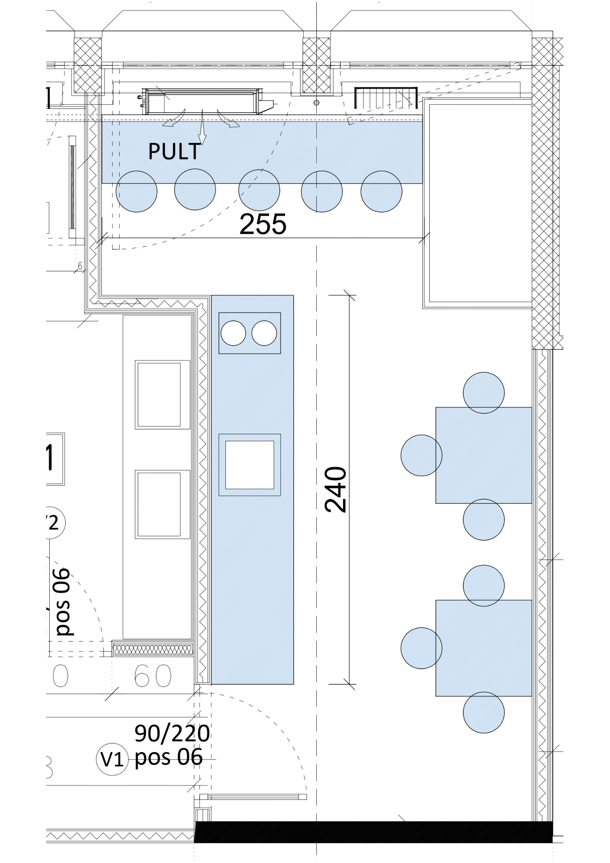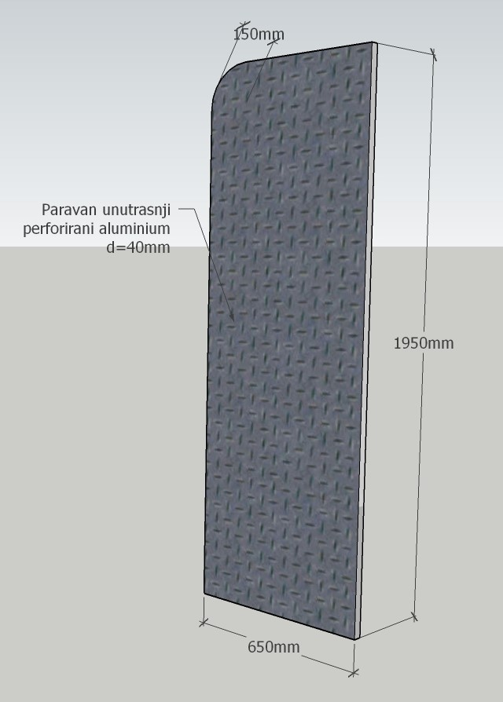

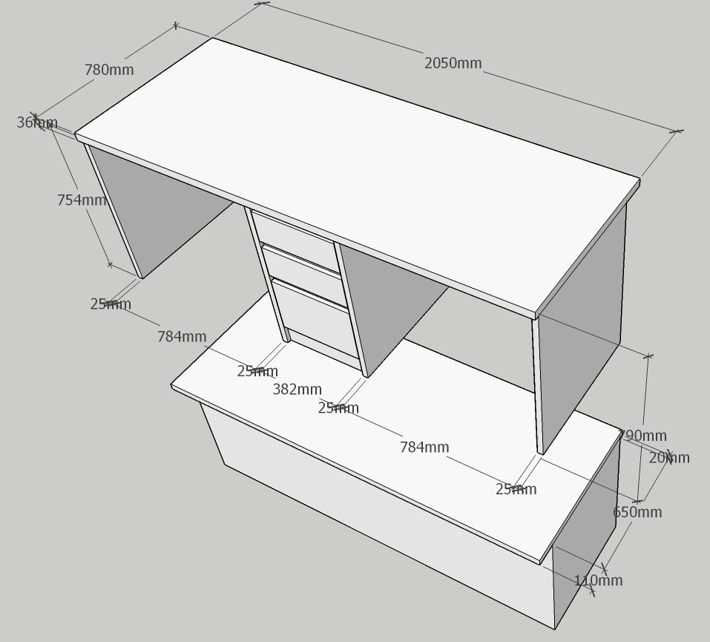
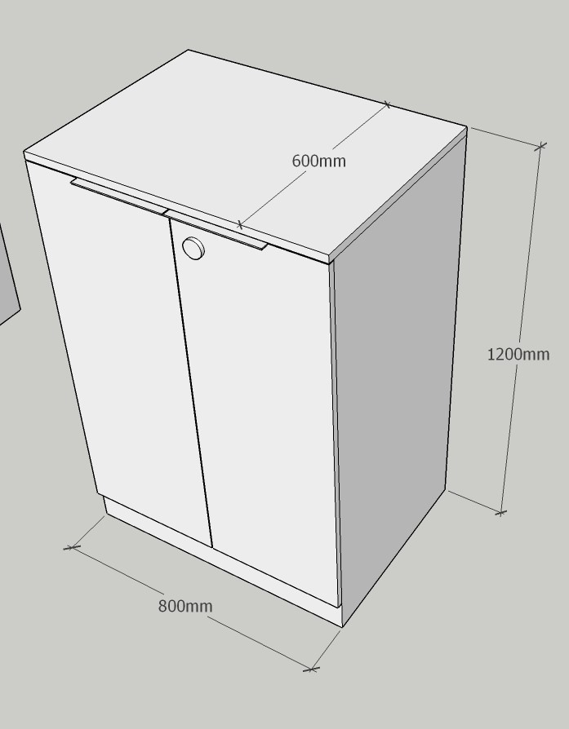
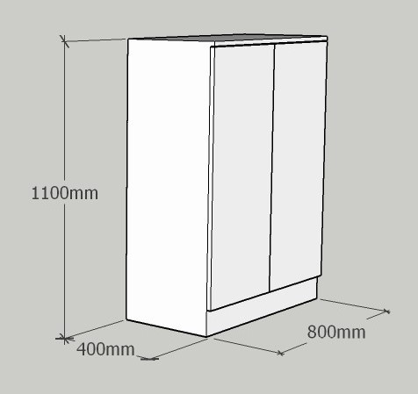

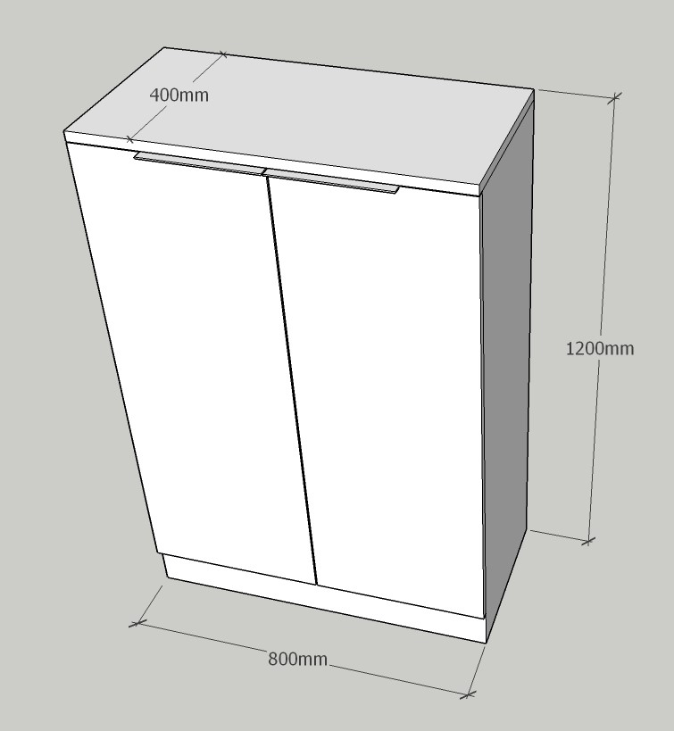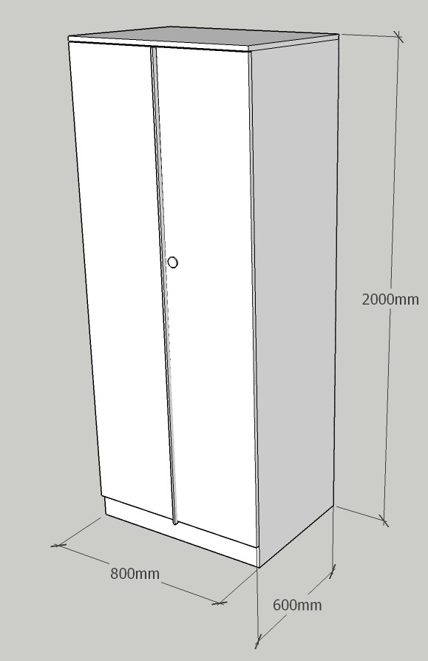
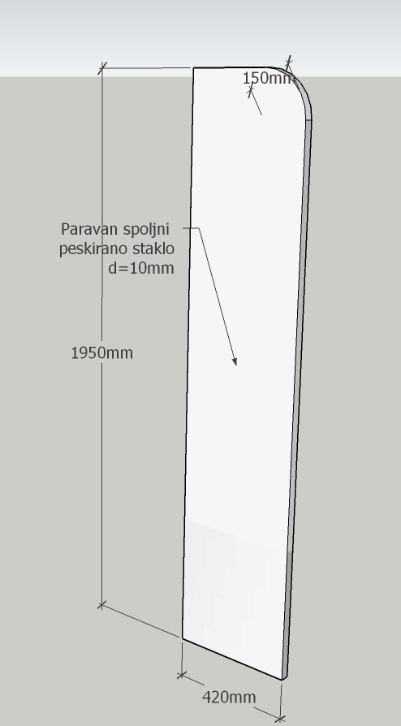
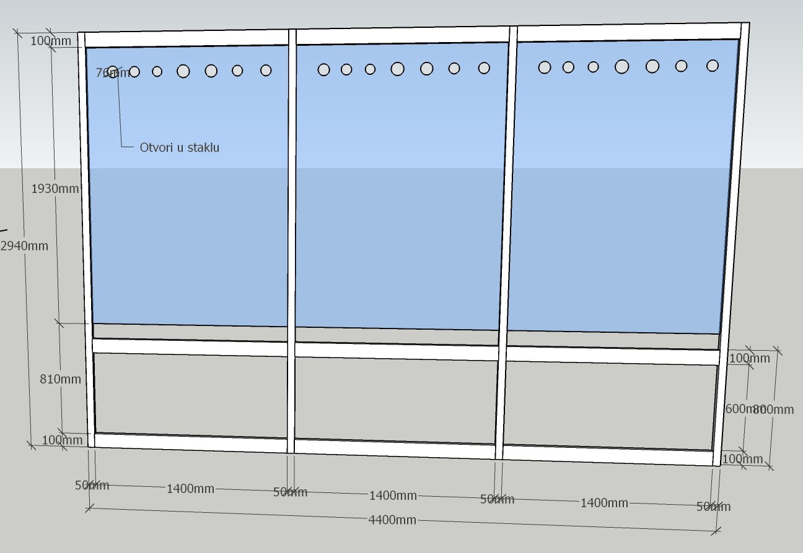
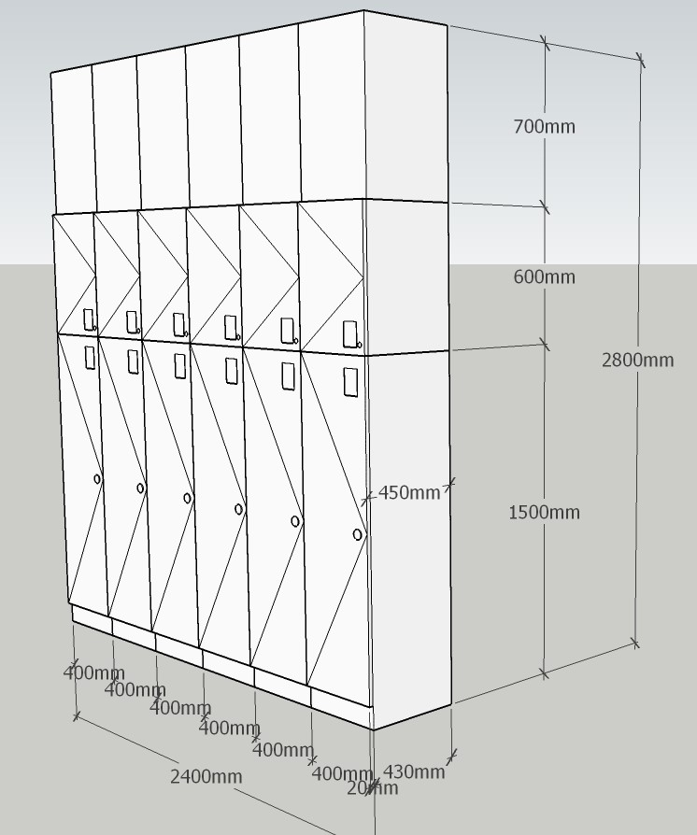
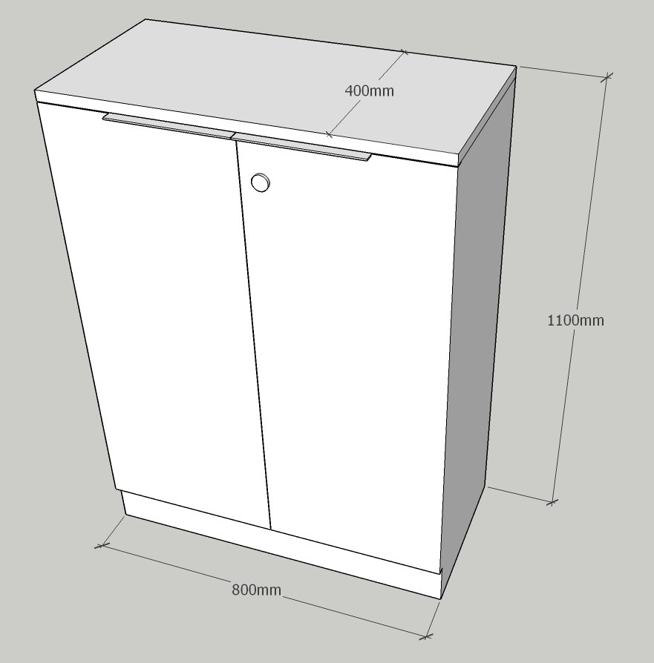
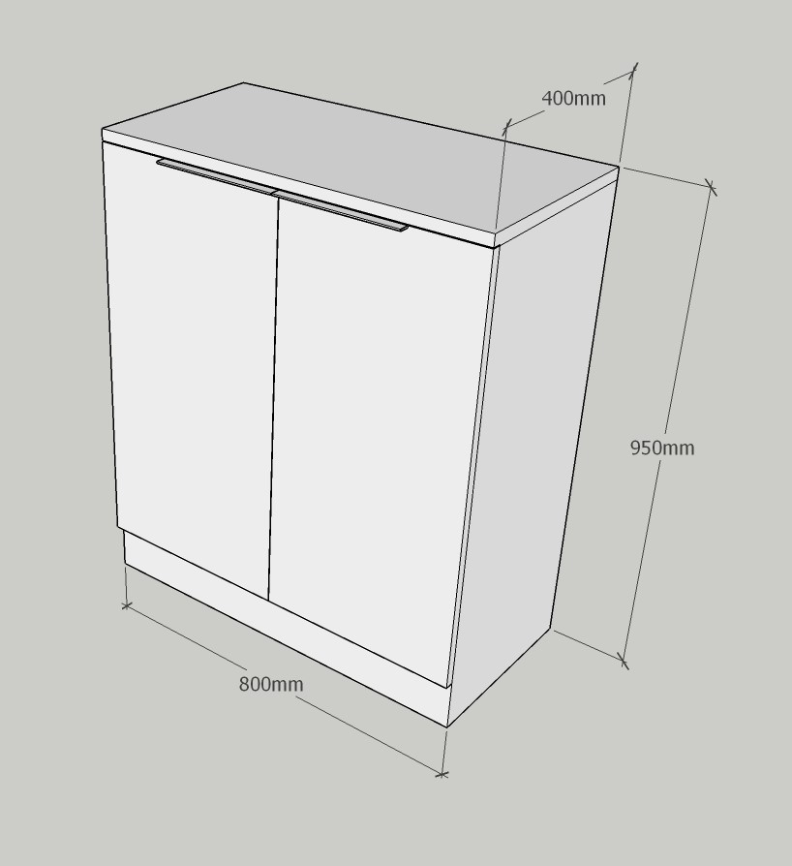

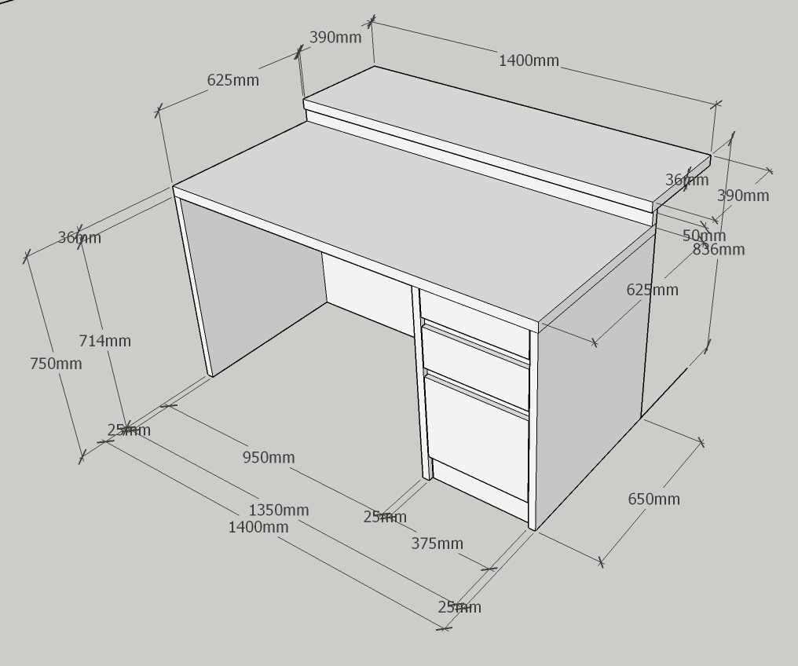
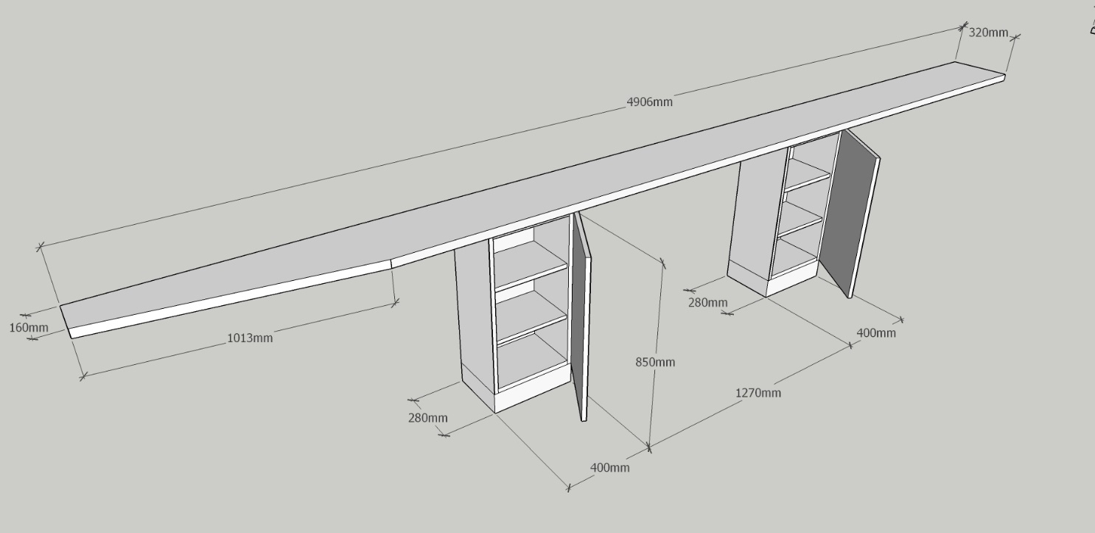
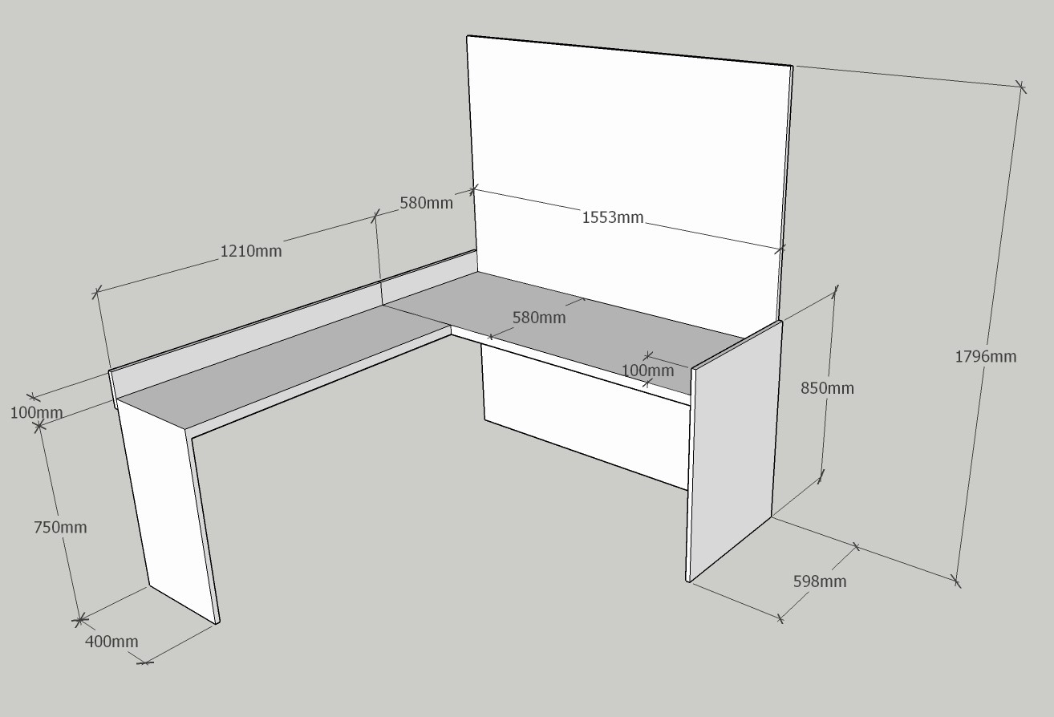
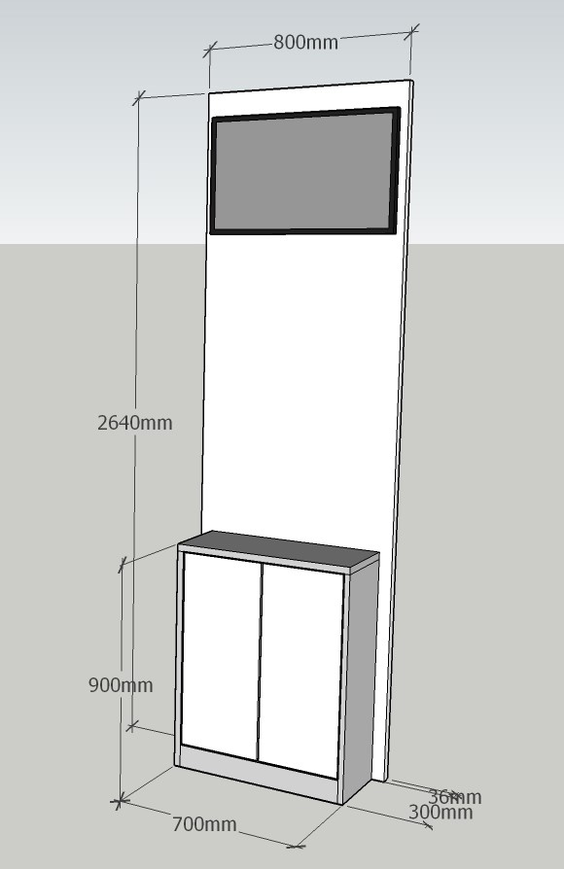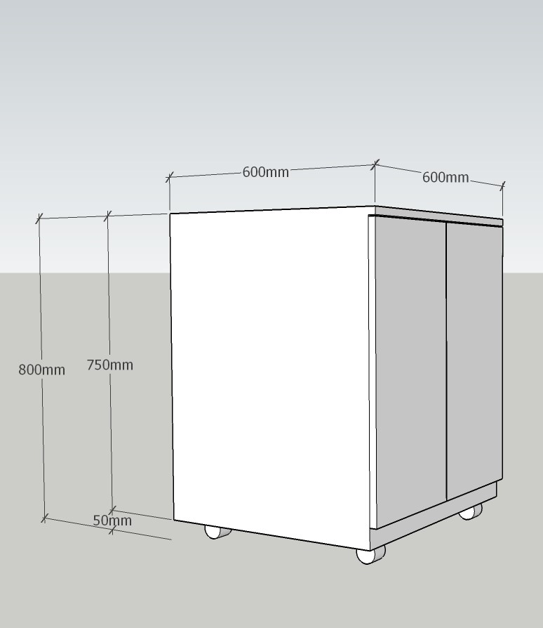

Delivery Requirements:

Currency of the Quotation: RSD
INCOTERMS: N/A
Item No | Description | UOM | Qty | Unit price | Total price
1. | Nabavka, isporuka I ugradnja kancelarijskog pisaceg stola od oplemenjene iverice dimenzije 140x65x75/83.6cm. Podsklop od univera u svetlo sivoj boji. Ploca stola debljine 25 mm, U beloj boji kantovana ABS trakom debljine po izboru I preporuci proizvodjaca. Podsklop stola čini fiokar sa tri srednje i jednom dubokom fiokom. Frontovi u beloj boji. Mere proveriti na licu mestaProcurement, delivery and installation of melamined cheepboards office desk, dimensions 140x65x75/83.6cm. Sub-assembly in light gray color. Table top d=25 mm thick, in white color edged with ABS strip. The sub-assembly of the table consists of a drawer with two medium and one deep drawer. Drawer fronts in white color. Confirm the meassurement on the site. | pcs | 3
2. | Nabavka, isporuka I ugradnja kancelarijskog pisaceg stola od oplemenjene iverice dimenzije 205x78x79cm. Podsklop od univera u svetlo sivoj boji. Ploca stola debljine 36 mm, U beloj boji kantovana ABS trakom. Podsklop stola čini fiokar sa tri srednje i jednom dubokom fiokom. Frontovi u beloj boji. Mere proveriti na licu mestaProcurement, delivery and installation of melamined cheepboards office desk, dimensions 205x78x79cm. Sub-assembly in light gray color. Table top d=36 mm thick, in white color edged with ABS strip. The sub-assembly of the table consists of a drawer with two medium and one deep drawer. Drawer fronts in white color. Confirm the meassurement on the site. | pcs | 1
3. | Nabavka, isporuka I ugradnja ugradne komodeod oplemenjene iverice koja se sastoji od parapetne ploče d=25mm i dva fiokara. Ukupne dimenzije 490x32x85cm. Podsklop od univera u svetlo sivoj boji. Ploca komode debljine 25 mm, u beloj boji kantovana ABS trakom. Podsklop stola čine dve komode sa policama i jednim okretnim vratima. Frontovi u beloj boji. Mere proveriti na licu mestaProcurement, delivery and installation of a melamined cheepboards built-in chest of drawers . The element consisting of a parapet plate d=25mm and two chest with shelves and doors. Total dimensions 490x32x85cm. Light gray sub-assembly. chest top tchikness 25 mm thick, white color edged with ABS tape. The sub-assembly of the table consists of two chests with shelves with shelves and one door. Door fronts in white color. Confirm the meassurement on the site. | pcs | 1
4. | Nabavka, isporuka I ugradnja komode od oplemenjene iverice koja se sastoji od gornje ploče i komode sa policama i vratima. Ukupne dimenzije 80x40x120cm. Podsklop od univera u svetlo sivoj boji sa tri police i vratima. Gornja ploca komode debljine 25 mm, u beloj boji kantovana ABS trakom. Vrata komode od oplemenjene iverice d=18mm u beloj boji. Vrata opremljena linijskom ruckom, bravom za zaključavanje i dva ključa.Procurement, delivery and installation of a built-in chest of drawers from melamined cheepboards. The element consisting of a parapet plate and chest with shelves and doors. Total dimensions 80x40x120cm. Light gray sub-assembly. chest top tchikness 25 mm thick, white color, edged with ABS tape. The sub-assembly of the table consists of chests with three shelves and one door. Doors equiped with metal lined handles, lock and two keys. | pcs | 1
5. | Nabavka, isporuka I ugradnja komode od oplemenjene iverice koja se sastoji od gornje ploče i komode sa policama i vratima. Ukupne dimenzije 80x40x120cm. Podsklop od univera u svetlo sivoj boji sa tri police i vratima. Gornja ploca komode debljine 25 mm, u beloj boji kantovana ABS trakom. Vrata komode od oplemenjene iverice d=18mm u beloj boji.Procurement, delivery and installation of a built-in chest of drawers from melamined cheepboards. The element consisting of a parapet plate and chest with shelves and doors. Total dimensions 80x40x120cm. Light gray sub-assembly. chest top tchikness 25 mm thick, white color, edged with ABS tape. The sub-assembly of the table consists of chests with three shelves and one door. Door fronts melamined cheepboards d=18mm, white color.Doors equiped with metal lined handles, lock and two keys. | pcs | 2
6 | Nabavka, isporuka I ugradnja komode od oplemenjene iverice koja se sastoji od gornje ploče i komode sa policama i vratima. Ukupne dimenzije 80x40x110cm. Podsklop od univera u svetlo sivoj boji sa tri police i vratima. Gornja ploca komode debljine 25 mm, u beloj boji kantovana ABS trakom. Vrata komode od oplemenjene iverice d=18mm u beloj boji. Vrata opremljena linijskom ruckom, bravom za zaključavanje i dva ključa..  Procurement, delivery and installation of a built-in chest of drawers from melamined cheepboards. The element consisting of a parapet plate and chest with shelves and doors. Total dimensions 80x40x110cm. Light gray sub-assembly. chest top tchikness 25 mm thick, white color, edged with ABS tape. The sub-assembly of the table consists of chests with three shelves and one door. Door fronts melamined cheepboards d=18mm, white color. Doors equiped with metal lined handles, lock and two keys. | pcs | 2
7 | Nabavka, isporuka I ugradnja komode od oplemenjene iverice koja se sastoji od gornje ploče i komode sa policama i vratima. Ukupne dimenzije 80x40x95cm. Podsklop od univera u svetlo sivoj boji sa tri police i vratima. Gornja ploca komode debljine 25 mm, u beloj boji kantovana ABS trakom. Vrata komode od oplemenjene iverice d=18mm u beloj boji. Vrata opremljena linijskom ruckom.  Procurement, delivery and installation of a built-in chest of drawers from melamined cheepboards. The element consisting of a parapet plate and chest with shelves and doors. Total dimensions 80x40x95cm. Light gray sub-assembly. chest top tchikness 25 mm thick, white color, edged with ABS tape. The sub-assembly of the table consists of chests with three shelves and one door. Door fronts melamined cheepboards d=18mm, white color. Doors equiped with metal lined handles. | pcs | 2
8 | Nabavka, isporuka I ugradnja komode od oplemenjene iverice koja se sastoji od gornje ploče i komode sa policama i vratima. Ukupne dimenzije 80x60x200cm. Podsklop od univera u svetlo sivoj boji sa pet polica i vratima. Gornja ploca komode debljine 25 mm, u beloj boji kantovana ABS trakom. Vrata komode od oplemenjene iverice d=18mm u beloj boji. Vrata opremljena linijskom ruckom, bravom za zaključavanje i dva ključa.  Procurement, delivery and installation of a built-in chest of drawers from melamined cheepboards. The element consisting of a parapet plate and chest with shelves and doors. Total dimensions 80x60x200cm. Light gray sub-assembly. chest top tchikness 25 mm thick, white color, edged with ABS tape. The sub-assembly of the table consists of chests with five shelves and one door. Door fronts melamined cheepboards d=18mm, white color. Doors equiped with metal lined handles, lock and two keys. | pcs | 3
9 | Nabavka, isporuka I ugradnja komode za printer izrađene od od oplemenjene iverice. Komoda je opremljena sa silikonskim točkićima i sastoji se od gornje ploče i komode sa policama i vratima. Ukupne dimenzije 60x60x80cm. Podsklop od univera u svetlo sivoj boji sa tri police i vratima. Gornja ploca komode debljine 25 mm, u beloj boji kantovana ABS trakom. Vrata komode od oplemenjene iverice d=18mm u beloj boji.  Procurement, delivery and installation of a chest for printer. Chest equiped with silicone wheel . Chest is assembled from melamined cheepboards. The element consisting of a top plate and chest with shelves and doors. Total dimensions 60x60x80cm. Light gray sub-assembly. chest top tchikness 25 mm thick, white color, edged with ABS tape. The sub-assembly of the table consists of chests with three shelves and one door. Door fronts melamined cheepboards d=18mm, white color. | pcs | 1
10 | Nabavka, isporuka I ugradnja ormana dimenzije 240x280cm izrađenog od oplemenjene iverice d=18mm. Orman se sastoji od 12 oramrića sa okretnim vratima i maskom iznad vrata. . Podsklop od univera u svetlo sivoj boji. Vrata komode od oplemenjene iverice d=18mm u beloj boji. Vrata sa numeracijom, opremljena bravom za zaključavanje i dva ključa sa odgovarajućom numeracijom. Mere proveriti na licu mesta.  Procurement, delivery and installation of a 240x280cm cabinet made of meaminaed chipboard, tchikness 18mm. The wardrobe consists of 12 cabinets with doors and a front panel covering above the door. Light gray unibody base. Dresser door made of melamined chipboard , tchikness 18mm in white color. Door wtih visible numeration, equipped with a lock and two keys with corresponding numberation. Confirm the meassurement on the site. | set | 1
11 | Nabavka, isporuka I ugradnja kancelarijskog pisaceg stola od oplemenjene iverice dimenzije 160x60x75/180cm plus ugaoni deo 120cmx40cmx75cm. Podsklop od univera u svetlo sivoj boji. Ploca stola debljine 25 mm, U beloj boji kantovana ABS trakom. Podsklop stola Od oplemenjene iverice d=25mm.  Procurement, delivery and installation of melamined cheepboards office desk, dimensions 160x60x75/180cm and side table dimension 120cmx40cmx75cm . Sub-assembly in light gray color. Table top d=25 mm thick, in white color edged with ABS strip. The sub-assembly of the table consists of a drawer with two medium and one deep drawer. Drawer fronts in white color. | set | 1
12 | Nabavka, isporuka I ugradnja komode od oplemenjene iverice dimenzije 70x30x90cm sa delom za TV sistema QMS, dimenzije 80x3,6x294cm. Podsklop od univera u svetlo sivoj boji. Ploca komode debljine 25 mm, U beloj boji kantovana ABS trakom.  Procurement, delivery and installation of melamined cheepboard chest dimension 70x30x90cm with element for TV as a part of the QMS system, dimensions 80x3,6x294cm. Sub-assembly in light gray color. Table top d=25 mm thick, in white color edged with ABS strip. | set | 1
13 | Aluminijumska pregrada ostakljena laminiranim staklom d=5.5.1.mm sa otvorima u staklu za ventilaciju prosotra.  Aluminium framed partition Glazed with laminated glass 6.6.2mm. with ventilation wholes in the glass panel. Dimension 4400mmx2940mm. | set | 1
14 | Panel od perforiranog aluminijumskog lima debljine 40mm. Dimenzije panela 650x1950mm.  10mm thick tempered sandblasted glass panel. Panel dimensions 420x1950mm.  Panel made of perforated aluminum sheet 40mm thick. Panel dimensions 650x1950mm. | pcs | 2
15 | Panel od kaljenog peskiranog stakla debljine 10mm. Dimenzije panela 420x1950mm.  10mm thick tempered sandblasted glass panel. Panel dimensions 420x1950mm. | pcs | 2
16 | Demontaža, prenos i popnovna monta-a kuhinje u novoj kuhinji. Dimenzije 240cm sa dodatnim pultom dužine 255cm.  Dismantling, transfer and reassembly of the kitchen in the new kitchen. Dimensions 240 cm with an additional counter length 255 cm. | set | 1
Total Price
Transportation Price
Insurance Price
Installation Price
Training Price
Other Charges (specify)
Total Final and All-inclusive Price

COMPANY PROFILE (Vendor Information Form)
Item Description | Detail
Legal name of bidder* | Click or tap here to enter text.
Legal Address (house no, street name, zip code, city*, region*, country*) | Click or tap here to enter text.
Website | Click or tap here to enter text.
Registration date* and VAT number* | Click or tap here to enter text. Click or tap here to enter text.
Legal structure | Choose an item.
Business type/industry category* | ☐ Direct Producer/Manufacturing ☐ Reseller/Distributor/Service Provider
Are you a UNGM registered vendor? | ☐ Yes ☐ No If yes, insert UNGM Vendor Number
Do you provide services/goods internationally? | ☐ Yes ☐ No If no, in which country: Click or tap here to enter text.
Contact information* | Company Tel/Mobile: Click or tap here to enter text.  Company Email: Click or tap here to enter text.  Company Website: Click or tap here to enter text.  Contact Person 1:Click or tap here to enter text.  Contact Person 2: Click or tap here to enter text.
Disability inclusive business* | ☐ Yes ☐ No
Women-owned/controlled* | ☐ Yes ☐ No
Bank Information | Bank Name: Click or tap here to enter text.  Bank Address: Click or tap here to enter text.  IBAN: Click or tap here to enter text.  SWIFT/BIC: Click or tap here to enter text.  Account Currency: Click or tap here to enter text.  Bank Account Number: Click or tap here to enter text.  Other relevant information: Click or tap here to enter text.

BIDDER’S DECLARATION OF CONFORMITY
Yes | No
☐ | ☐ | On behalf of the vendor, I hereby represent and warrant that neither the vendor, nor any person having powers of representation, decision-making or control over it or any member of its administrative, management or supervisory body, has been the subject of a final judgement or final administrative decision for one of the following reasons: bankruptcy, insolvency or winding-up procedures; breach of obligations relating to the payment of taxes or social security contributions; grave professional misconduct, including misrepresentation, fraud; corruption; conduct related to a criminal organisation; money laundering or terrorist financing; terrorist offences or offences linked to terrorist activities; child labour and other trafficking in human beings, any discriminatory or exploitative practice, or any practice that is inconsistent with the rights set forth in the Convention on the Rights of the Child or other prohibited practices; irregularity; creating or being a shell company.
☐ | ☐ | On behalf of the vendor, I further represent and warrant that the vendor is financially sound and duly licensed.
☐ | ☐ | On behalf of the vendor, I further represent and warrant that the vendor has adequate human resources, equipment, competence, expertise and skills necessary to complete the contract fully and satisfactorily, within the stipulated completion period and in accordance with the relevant terms and conditions.
☐ | ☐ | On behalf of the vendor, I further represent and warrant that the vendor complies with all applicable laws, ordinances, rules and regulations.
☐ | ☐ | On behalf of the vendor, I further represent and warrant that the vendor will in all circumstances act in the best interests of IOM.
☐ | ☐ | On behalf of the vendor, I further represent and warrant that no official of IOM or any third party has received from, will be offered by, or will receive from the vendor any direct or indirect benefit arising from the contract.
☐ | ☐ | On behalf of the vendor, I further represent and warrant that the vendor has not misrepresented or concealed any material facts during the contracting process.
☐ | ☐ | On behalf of the vendor, I further represent and warrant that the vendor will respect the legal status, privileges and immunities of IOM as an intergovernmental organization.
☐ | ☐ | On behalf of the vendor, I further represent and warrant that neither the vendor nor any persons having powers of representation, decision-making or control over the vendor or any member of its administrative, management or supervisory body are included in the most recent Consolidated United Nations Security Council Sanctions List (the “UN Sanctions List”) or are the subject of any sanctions or other temporary suspension. The vendor will immediately disclose to IOM if it or they become subject to any sanction or temporary suspension.
☐ | ☐ | On behalf of the vendor, I further represent and warrant that the vendor does not employ, provide resources to, support, contract or otherwise deal with any person, entity or other group associated with terrorism as per the UN Sanctions List and any other applicable anti-terrorism legislation.
☐ | ☐ | On behalf of the vendor, I further represent and warrant that, the vendor will apply the highest ethical standards, the principles of efficiency and economy, equal opportunity, open competition and transparency, and will avoid any conflict of interest.
☐ | ☐ | On behalf of the vendor, I further represent and warrant that the vendor undertakes to comply with the Code of Conduct, available at https://www.ungm.org/Public/CodeOfConduct.
☐ | ☐ | It is the responsibility of the vendor to inform IOM immediately of any change to the information provided in this Declaration.
☐ | ☐ | On behalf of the vendor, I certify that I am duly authorized to sign this Declaration and on behalf of the vendor I agree to abide by the terms of this Declaration for the duration of any contract entered into between the vendor and IOM.
☐ | ☐ | IOM reserves the right to terminate any contract between IOM and the vendor, with immediate effect and without liability, in the event of any misrepresentation made by the vendor in this Declaration.

Signature:
Name: Click or tap here to enter text.
Title: Click or tap here to enter text.
Date: Click or tap to enter a date.

If company id not registered in UNGM or with IOM. If supplied to IOM already, please indicate if there are any changes to be incorporated in the vendor information sheet signed earlier
This form is mandatory to fill in and sign by every vendor who submits quotation

